5.58: The hooks exert forces on the ends of the rope. At each hook, the force that the hook exerts and the force due to the tension in the rope are an action-reaction pair.
The vertical forces that the hooks exert must balance the weight of the rope, so each hook exerts an upward vertical force of 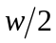 on the rope. Therefore, the downward force that the rope exerts at each end is 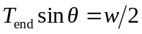, so 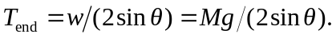
b) Each half of the rope is itself in equilibrium, so the tension in the middle must balance the horizontal force that each hook exerts, which is the same as the horizontal component of the force due to the tension at the end; 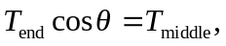 so
(c) Mathematically speaking, 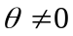 because this would cause a division by zero in the equation for 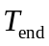 or 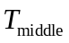. Physically speaking, we would need an infinite tension to keep a non-massless rope perfectly straight.

